Homework on gene expression microarray analysis in R/Bioconductor
More detailed information is available in the presentation entitled ‘Gene expression microarray profiling in practice’ given at 19/11/2013

Exercise: We will compare the colonic gene expression microarray profiles (U133plus2 arrays) between patients with ulcerative colitis (UC, n=8) and healthy controls (n=6) to identify which genes (probe sets) are differentially expressed between both groups. Next, we will study which biological pathways are overrepresented in the list of significant genes.
Due data: 8 Jan 2014 @ midnight

Download R - Bioconductor:
- Download the latest version of R (R 3.0.2; http://cran.r-project.org/)
- Download the latest version of Bioconductor (http://www.bioconductor.org/download) in R 3.0.2 with following R codes:
R commands:
source("http://bioconductor.org/biocLite.R")
biocLite()

- Download the following packages in R 3.0.2:
R commands:
biocLite(c("affy","hgu133plus2.db","hgu133plus2cdf","genefilter","limma"," gplots","annaffy"))

Load the data in R:
- Make a file on your computer containing all raw data (.cel files) and phenoData.txt. There are in total 14 cel files (8 .cel files from 8 patients with ulcerative colitis and 8 .cel files from normal controls) and a phenodata.txt file containing the phenotype information).
- Go to FILE in R 3.0.2 Change dir menu item (the file with the raw data (cel.files) and phenoData.txt)

Data analysis:
- Normalization with RMA method
R commands:
library(affy)
library(hgu133plus2.db)
pd<-read.AnnotatedDataFrame("phenoData.txt",header=TRUE,row.names=1)
datarma<-justRMA(filenames=rownames(pData(pd)),phenoData=pd)
write.exprs(datarma, file="datarma.txt")

Question:
How many probe set IDs do we have for further data analysis? (see datarma.txt file that is saved in your working directory)
- Non-specific filtering: To eliminate non-relevant probe sets
R commands:
eset<-datarma[,pData(datarma)[,"Disease"]%in%c("UC","control")]
dim(eset)
pData(eset)
library(genefilter)
f1<-pOverA(0.10,log2(100))
f2<-function(x)(IQR(x)>0.5)
ff<-filterfun(f1,f2)
selected<-genefilter(eset,ff)
sum(selected)
esetSub<-eset[selected,]
table(selected)
esetSub

Question:
How many features and samples have ‘eset’?

Why are we doing a filtering and which filter criteria did we use in this exercise?

After filtering, how many probe sets are left for further data analysis?
- Unsupervised average-linkage hierarchical clustering on filtered probe sets
R commands:
dat<-exprs(esetSub)
dim(dat)
d<-dist(t(dat))
hc<-hclust(d,method="average")
plot(hc,cex=0.8)
labels<-pData(esetSub)[,"Disease"]
plot(hc,cex=0.8,labels)

Question:
Explain the figure that you get.
- Identifying differentially expressed genes (probe sets) between UC and controls.
R commands:
esetsel<-esetSub[,pData(esetSub)[,"Disease"]%in%c("UC","control")]
dim(esetsel)
library(limma)
f<-factor(as.character(esetsel$Disease))
f
design<-model.matrix(~f)
design
fit<-lmFit(exprs(esetsel),design)
fit2<-eBayes(fit)
options(digits=2)
topTable(fit2,coef=2,adjust="BH",number=100)
topTableall<-topTable(fit2,coef=2,adjust="BH",number=9183)
write.table(topTableall,file="topTableall.xls",sep="\t",quote=F)
topTableall <- read.delim(file="topTableall.xls", header=T, sep="\t")

(ATTENTION: open the file ‘topTableall.xls’ and insert in A1 of the excel file an extra cell by shifting the cells right and give the cell A1 the name ‘ID’):
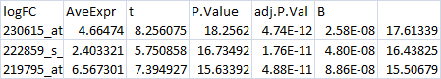
->
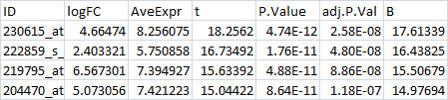
dim(topTableall)
colnames(topTableall)
gn<-as.character(topTableall$ID)
genesymbols<-unlist(mget(gn,hgu133plus2SYMBOL,ifnotfound=NA))
topTableallgenesymbols<-data.frame(topTableall,genesymbols)
write.table(topTableallgenesymbols,file="topTableallgenesymbols.xls",sep="\t",quote=F)
topTablesig<-topTableall[topTableall$adj.P.Val<0.05,]
dim(topTablesig)
topTablesig2FC<-topTableall[topTableall$adj.P.Val<0.05&(topTableall$logFC>1|topTableall$logFC<(-1)),]
dim(topTablesig2FC)
uptopTablesig2FC<-topTableall[topTableall$adj.P.Val<0.05&(topTableall$logFC>1),]
downtopTablesig2FC<-topTableall[topTableall$adj.P.Val<0.05&(topTableall$logFC<(-1)),]
dim(uptopTablesig2FC)
dim(downtopTablesig2FC)

Question:
Which package in R did we use to identify differentially expressed genes?

Which method did we use for multiple testing correction?

How many probe sets are significantly (adjusted p-value <5%) differentially expressed between UC and control? In this list of significant probe sets, how many probe sets have >2-fold change? Please note that FC are logFC, e.g. logFC 1 = FC 2¹, logFC2, FC 2².

Which is the most significantly differentially expressed gene (probe set)? Is this gene up- or downregulated in UC vs. controls? (see also topTableallgenesymbols.xls in your working directory)

How many probe sets (genes) are >2-fold significantly INCREASED in UC vs. controls, and which gene (probe set) is most significant? (see also topTableallgenesymbols.xls in your working directory)

How many probe sets (genes) are >2-fold significantly DECREASED in UC vs. controls, and which gene (probe set) is the most significant one? (see also topTableallgenesymbols.xls in your working directory)

Bio Functional analysis:
- Go to Gene Ontology Enrichment Analysis Software Toolkit (GOEAST; http://omicslab.genetics.ac.cn/GOEAST/php/affymetrix.php ) Take in STEP ONE:’Homo Sapiens’ Take in STEP 2: ‘Human Genome U133 plus 2 array Paste in STEP 3 the significant probe set IDs that are >2-fold increased in UC vs. controls (copy these probe sets IDs from topTableallgenesymbols.xls file that is present in your working directory) Please insert your mail address in STEP FIVE START ANALYSIS

Question:
Which GO-term involved the most significant genes/probe sets?

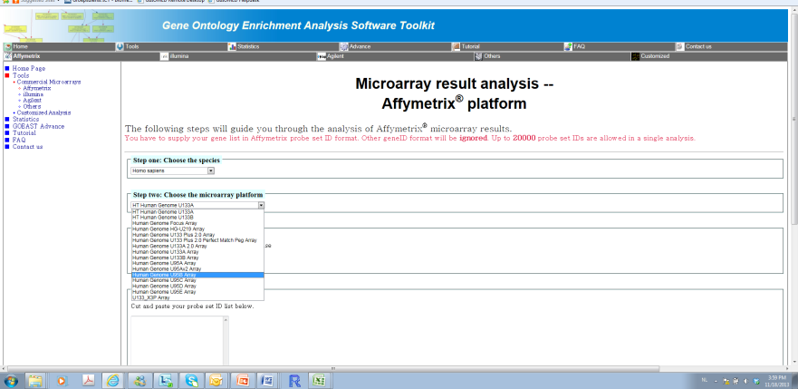

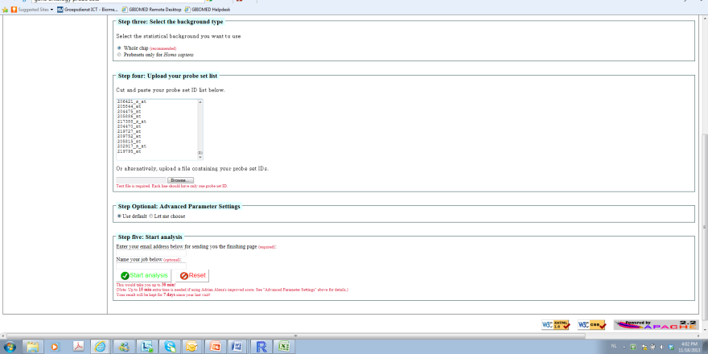

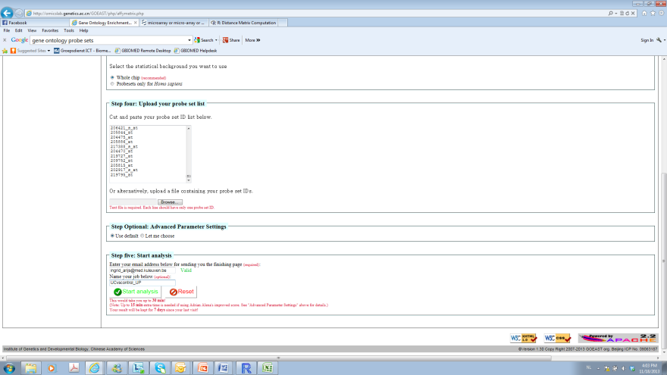

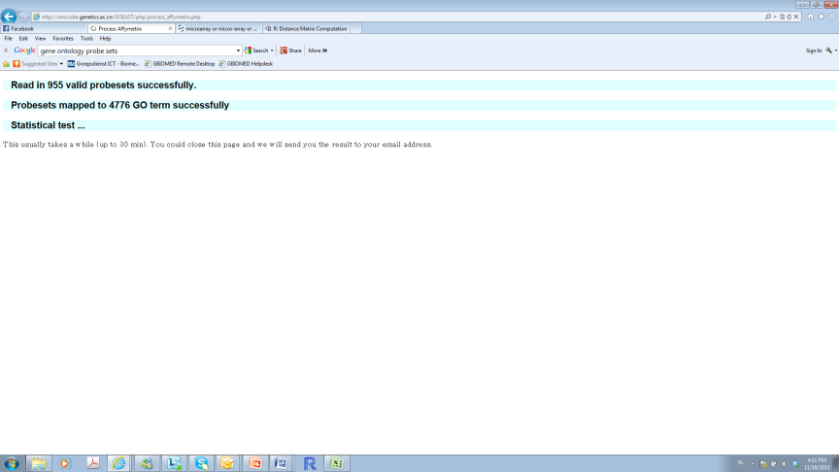

- Go to DAVID (http://david.abcc.ncifcrf.gov/) Functional annotation Paste the significant probe set IDs that are >2-fold increased in UC vs. controls (copy these probe sets IDs from topTableallgenesymbols.xls file that is present in your working directory) in the LEFT panel under STEP 1 (see figure below) In STEP 2, take as identifier AFFYMETRIX_3PRIME_IVT_ID (because we used U133plus2 arrays) In STEP 3, take the option ‘gene list’ In STEP 4, submit list Click on chart under Gene Ontology Category Biological pathways (GOTERM_BP_ALL) (see figure below) Biological pathways which are most predominant to the list of increased genes in UC vs. controls are given.

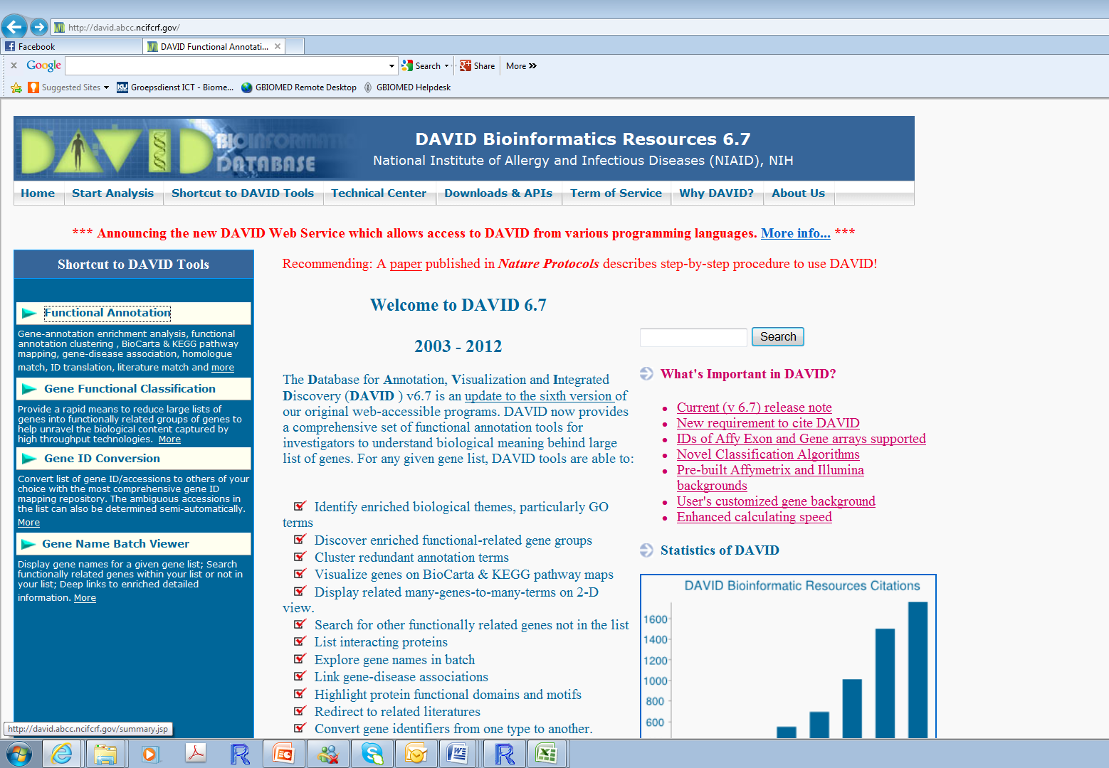

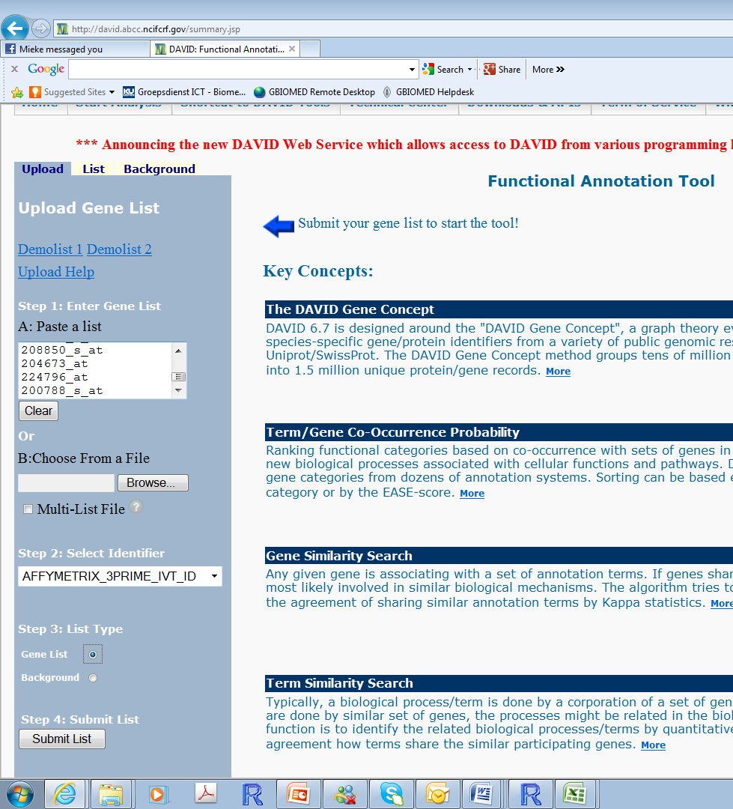

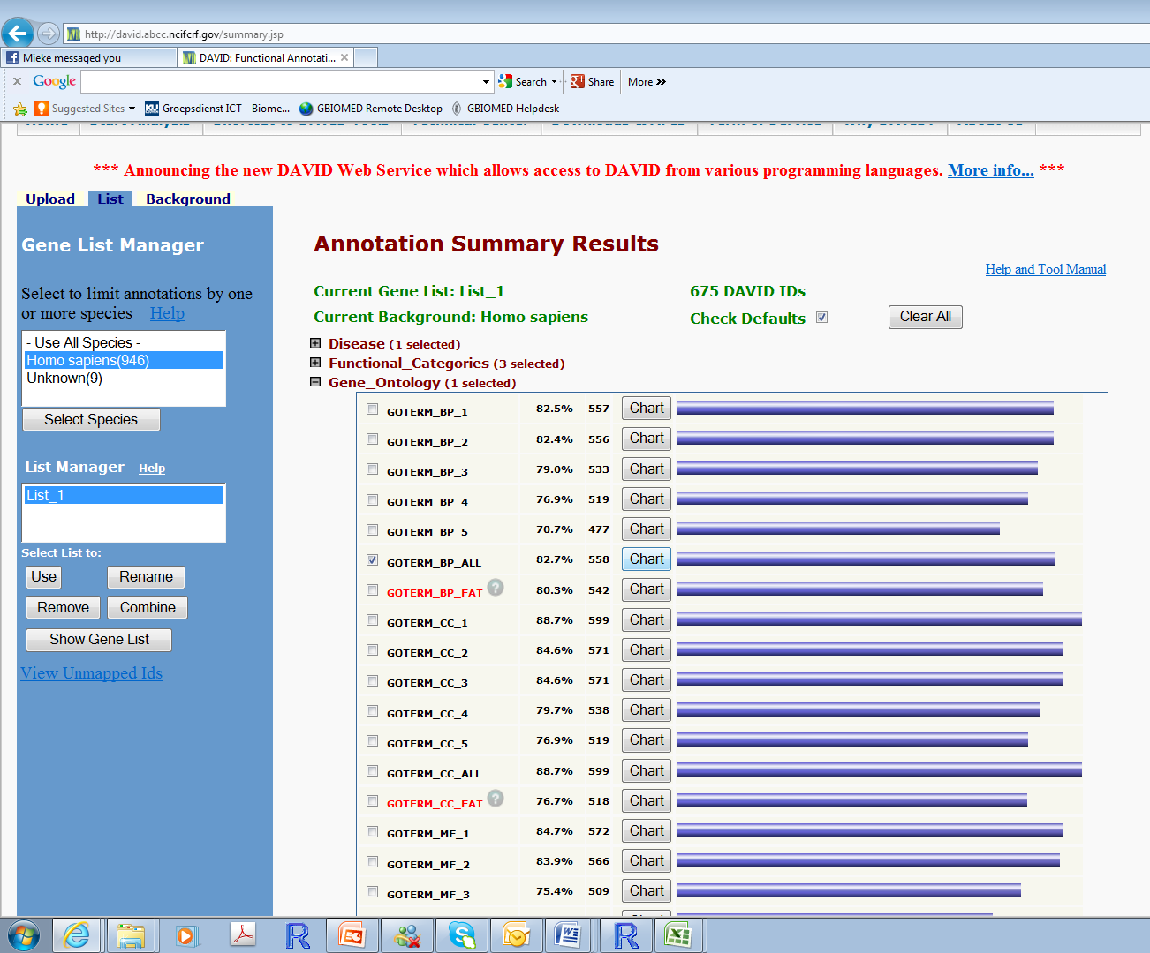

Question:
Give the top 5 biological pathways that are most significant to the dataset of increased (>2-fold) genes in UC vs. controls? Are these pathways relevant for UC?

